Submitted to: Anu Priyam

Submitted by: Arpita Rani

OSGI SERVICE ASSIGNMENT

Configuration
package com.project.core.config;

import org.osgi.service.metatype.annotations.AttributeDefinition;
import org.osgi.service.metatype.annotations.ObjectClassDefinition;

@ObjectClassDefinition(
name = "Project Email Service Configuration",
description = "Email service for project work."
)
public @interface ProjectEmailServiceConfig {

@AttributeDefinition(name = "Sender Email ID")
String senderEmail();

@AttributeDefinition(name = "Sender Name")
String senderName();

@AttributeDefinition(name = "Receiver Email ID")
String receiverEmail();

@AttributeDefinition(name = "Receiver Name")
String receiverName();

@AttributeDefinition(name = "Email Subject")
String emailSubject();
}

Interface
package com.project.core.services;

public interface ProjectEmailService {
void sendEmail();
}

Implementation
package com.project.core.services.impl;

import org.slf4j.Logger;
import org.slf4j.LoggerFactory;
import com.day.cq.mailer.MessageGateway;
import com.day.cq.mailer.MessageGatewayService;

import org.apache.commons.mail.SimpleEmail;
import org.osgi.service.component.annotations.*;
import org.osgi.service.metatype.annotations.Designate;
import com.project.core.config.ProjectEmailServiceConfig;
import com.project.core.services.ProjectEmailService;

@Component(service = ProjectEmailService.class)
@Designate(ocd = ProjectEmailServiceConfig.class)
public class ProjectEmailServiceImpl implements ProjectEmailService {

private static final Logger LOGGER = LoggerFactory.getLogger(ProjectEmailServiceImpl.class);

@Reference
private MessageGatewayService messageGatewayService;

private ProjectEmailServiceConfig config;

@Activate
@Modified
protected void activate(ProjectEmailServiceConfig config) {
this.config = config;
LOGGER.info("[ProjectEmailService] Configuration activated successfully");
}

@Override
public void sendEmail() {

try {
if (config == null) {
LOGGER.error("[ProjectEmailService] Config is null");
return;
}
MessageGateway<SimpleEmail> gateway =
messageGatewayService.getGateway(SimpleEmail.class);

if (gateway == null) {
LOGGER.error("[ProjectEmailService] Message Gateway is Null");
return;
}

SimpleEmail email = new SimpleEmail();
email.setFrom(config.senderEmail(), config.senderName());
email.addTo(config.receiverEmail(), config.receiverName());
email.setSubject(config.emailSubject());
email.setMsg("Email sent from AEM OSGi Service.");

gateway.send(email);

LOGGER.info("[ProjectEmailService] Email sent successfully to {}",
config.receiverEmail());

} catch (Exception e) {
LOGGER.error("[ProjectEmailService] Failed to send email", e);
}
}
}

Servlet
package com.project.core.servlets;

import com.project.core.services.ProjectEmailService;
import org.apache.sling.api.SlingHttpServletRequest;
import org.apache.sling.api.SlingHttpServletResponse;
import org.apache.sling.api.servlets.SlingSafeMethodsServlet;
import org.osgi.service.component.annotations.Component;
import org.osgi.service.component.annotations.Reference;

import javax.servlet.Servlet;
import java.io.IOException;

@Component(
service = Servlet.class,
property = {
"sling.servlet.paths=/bin/sendEmail",
"sling.servlet.methods=GET"
}
)
public class EmailTriggerServlet extends SlingSafeMethodsServlet {

@Reference
private ProjectEmailService emailService;

@Override
protected void doGet(SlingHttpServletRequest request,
SlingHttpServletResponse response)
throws IOException {

emailService.sendEmail();
response.getWriter().write("Email Triggered Successfully!");
}
}

Runmodes
Dev
{
"senderEmail": "arpitarani1501@gmail.com",
"senderName": "Arpitaaa",
"receiverEmail": "221030055@juitsolan.in",
"receiverName": "Arpita development",
"emailSubject": "Email services"
}

Prod
{
"senderEmail": "arpitarani1501@gmail.com",
"senderName": "Arpitaaa",
"receiverEmail": "arpitarani1501@gmail.com",
"receiverName": "Arpita production",
"emailSubject": "Email services"
}

Output
OneDrive link: email service assignment.mp4

Images:

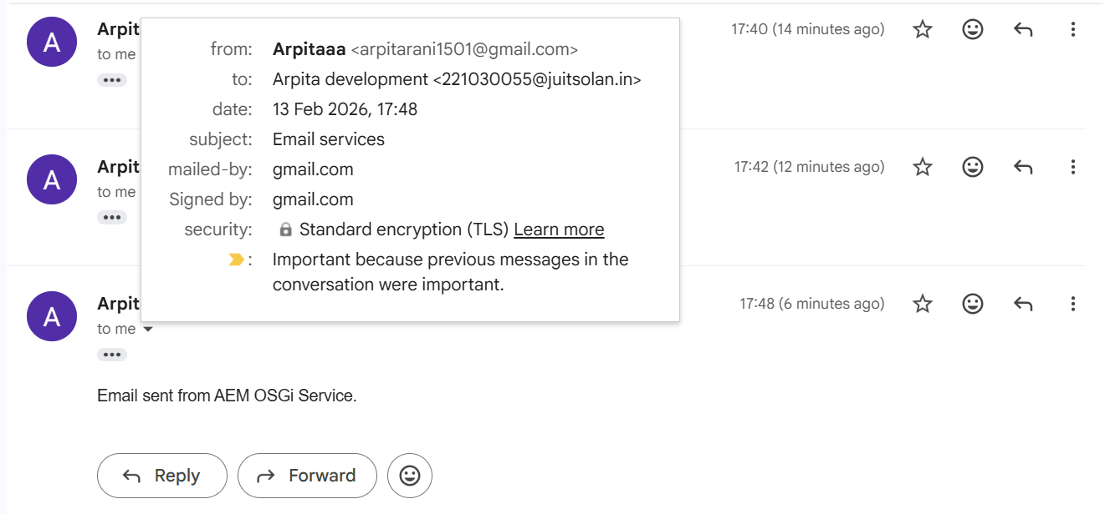

Logger snippet:

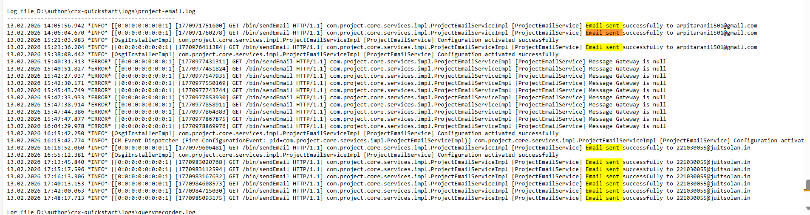

SMTP:

